**Design Document**

**Introduction**

The band “Monkees”, a pop-rock band from the 1960’s, has requested a web page.

**Interviews**

The following requirements have been determined form interviews with the band:

* The web page will primarily target fans and potential fans
* Make video and audio clips from the back catalogue accessible for the fans
* Any new material will be uploaded onto the website as it becomes available
* The website should also showcase their music
* Publicise availability to be booked at events (e.g. Weddings, Christmas parties etc.)
* Links to social media accounts Facebook, Twitter and YouTube

**Supplied resources**

The following resources have been supplied by the band for initial web site creation.

Audio:

* Clarksville.mp3
* DaydreamBeliever.mp3
* ImABeliever.mp3
* SteppingStone.mps

Images:

* album.jpg
* album2.jgp
* band.jpg
* cover.jpg
* cover2.pjg
* cover2.jpg
* cover3.jpg
* dj.jpg
* md.jpg
* mn.jpg
* monkees.jpg
* pt.jpg

**Online repositories**

Github: <https://github.com/demonkeyfire/monkees_website>

AWS Cloud9: <https://us-east-1.console.aws.amazon.com/cloud9/ide/cd1b81562a7446c8b1fdcc1f073dd57e>

Figma: <https://www.figma.com/file/ai2mcrlIqRzaTpNaq9nmGegd/monkees_website?node-id=0%3A1>

**Strategy**

|  |  |  |  |
| --- | --- | --- | --- |
| **Opportunity** | **Importance** | **Feasibility** | **I * F** |
| 1. Online Presence | 5 | 5 | 25 |
| 1. Fan access portal | 4 | 4 | 16 |
| 1. Host back catalogue | 4 | 3 | 12 |
| 1. Expandable with new music | 2 | 3 | 6 |
| 1. A showcase of music | 4 | 3 | 12 |
| 1. Booking capabilities | 2 | 2 | 4 |
| 1. Social media links | 3 | 5 | 15 |
| 1. Ease-of-use for older users | 5 | 3 | 15 |

Order of opportunities to be addressed:

1. A – Online presence
2. B – Fan access portal
3. G & H – Social Media Links & Ease-of-use for older users
4. C & E – Host back catalogue & A showcase of music
5. D – Expandable with new music
6. F – Booking capabilities

**Resources v. Implementation**

A = SUM(Importance) = 29

B = SUM(Feasibility = 28

A > B 🡪 Can just implement all items

**Making content appropriate**

The website will be designed to target current and new fans; therefore, the website usability needs to be designed for the least technologically capable, i.e. current fans. Assuming a user became a fan when the band started in 1966, and being a rock band the music was targeted at ~17 yr olds, the current age will be ~70 yrs old. The following guidelines will need to be followed for UI:

* Words & icons for links
* LARGE clear content
* 2-clicks for user to achieve goal

**User’s main use of site**

The website is targeted at fans. Assume a fan will want to visit site to listen/watch music and videos and track band’s bookings. These features need to be prominent, attractive and easy to access.

**Content display**

The site will be showcasing the band’s music and videos. The videos will be displayed first and music links underneath to make viewing the catalogue more exciting. All video and music links will be represented with an appropriate image. Future possibility: the music and videos will be rearrangeable and searchable.

**Scope**

Opportunities 1-5 will be done and if finished will move onto parts 5 & 6.

The website will be static using HTML5, CSS3 and BootStrap 4.3.1

**Conflicts**

No conflicts expected in the design.

**User need**

The user need is to be able view content published by the Monkees, and find new content easily as/when it is published, and view the band’s schedule and availability.

**Timeline**

|  |  |
| --- | --- |
| **Sprint** | **Time** |
| 1. Create wireframe | 0.5 day |
| 1. Basic HTML document | 0.25 day |
| 1. Header | 0.25 day |
| 1. Footer | 0.25 day |
| 1. Colouring | 0.5 day |
| 1. Content - Home | 0.5 day |
| 1. Content - Music | 0.5 day |
| 1. Content - Contact | 0.5 day |
| 1. Finalise phone design | 0.5 day |
| 1. Finalise desktop design | 0.5 day |
| **Total** | 4.25 days |

**Structure**

The structure of the website will be split between mobile and desktop responsive design.

**Content**

Web pages to be included:

* Home page
* Music
* Band Members
* Event Diary
* Contact page

**Mobile**

The homepage for the mobile site will be a single scrolling page will a “sub” version of the other pages, designed for ease-of-access and to encourage new fans by having all of the best angles of the band

The menu will be a collapsible “burger” icon that fills the entire viewport with the options.

**Desktop**

Navigation between the different web pages will be through standard navigation buttons in the header, which will remain the same between all web pages and static when the web page scrolls.

**Styling**

The web page will be styled in a similar fashion to the original band styling as determined from the album cover images.

A screenshot from Daydream Believer

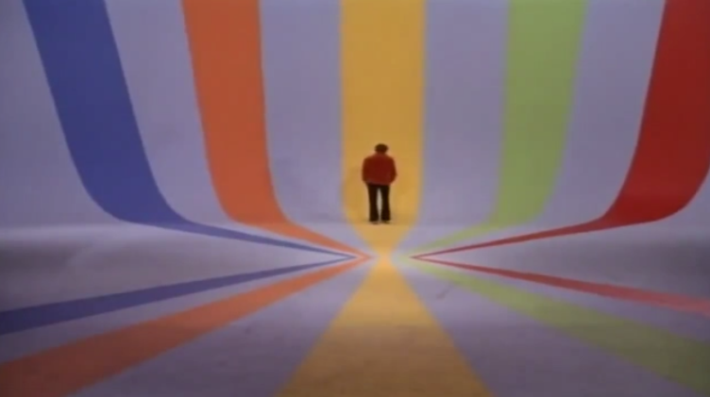

The colours were picked from the five coloured strips in the music video Daydream Believer. The image above was uploaded to the website <https://imagecolorpicker.com/> and the five colours were determined. The colours were then updated to more vibrant colours to compensate for the video quality and more modern styling.

|  |  |  |  |  |  |
| --- | --- | --- | --- | --- | --- |
| **Colour** | **Purple** | **Orange** | **Yellow** | **Green** | **Red** |
| Original HEX | #3E4079 | # AC5136 | # BF9042 | #7C8952 | #801E1B |
| New HEX | #4549B0 | #E46627 | #EAAE4A | #A6BA54 | #B82210 |

The Monkees guitar logo was downloaded from <https://seeklogo.com/vector-logo/94443/monkees> and converted from eps to png file format.

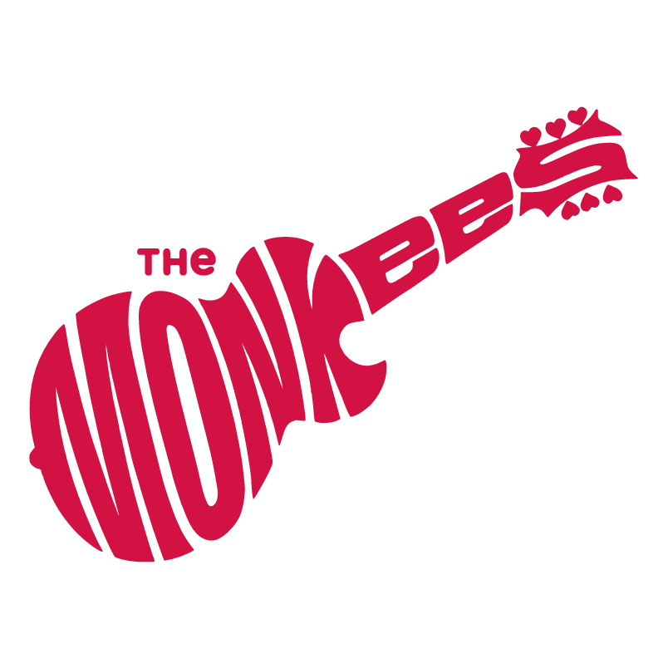

Reviewing the font styles used in the above logo and the monkees album covers a similar one was chosen from the free google fonts: Lakki Reddy.

<link href="https://fonts.googleapis.com/css?family=Lakki+Reddy&display=swap" rel="stylesheet">

**Skeleton**

The wireframe can be found at <https://www.figma.com/file/ai2mcrlIqRzaTpNaq9nmGegd/monkees_website?node-id=0%3A1>

Took the Monkees logo, and modified it to conform to the styling across the rest of the web page.

